HOW TO ADD YOUR Heartland Bank CARD TO ELECTRONIC WALLET “E-WALLET” - APPLE PAY (IPHONE)
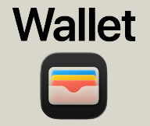
- Open Wallet App (you can say “Hey Siri, open my wallet app”)
This is what your Apple Wallet app looks like

- Tap the “+” Button in Top Right Corner
- Follow Prompts to Scan/ Enter Card Information
- Select Debit or Credit Card
- You’re Ready to Tap and Pay via E-Wallet

HOW TO ADD YOUR heartland bank CARD TO ELECTRONIC WALLET “E-wALLET” – Google Wallet (ANDROID)

- Open Google Wallet App (you can say “Hey Google, open my wallet app”)
This is what your Google Wallet app looks like

- Tap “Add to Wallet” ⟶ Payment Card
- Follow Prompts to Scan/ Enter Card Information
- You’re Ready to Tap and Pay via E-Wallet on your phone

